**Software Engineering**

**Project Title:** GitHome

**Date of Submission:** 4-Dec-23

**Submitted to:** Dr. Imran Rao

**Group members:**

|  |  |
| --- | --- |
| **Name** | **CMS ID** |
| Rayyan Athar Hussain | 365691 |
| Muhammad Toasiq | 398757 |
| Hamaz Hamza | 365670 |
| Omer Farooq | 377187 |
| Abdullah Fazeel | 337188 |

**1. Context Level Diagram:**

The context level diagram shows two external entities that communicate with the system. The user interfaces the system via Command Line Interface commands and receives output of these commands and the system communicates with the operating system mainly for file handling and management.

**2. Architecture Diagram:**

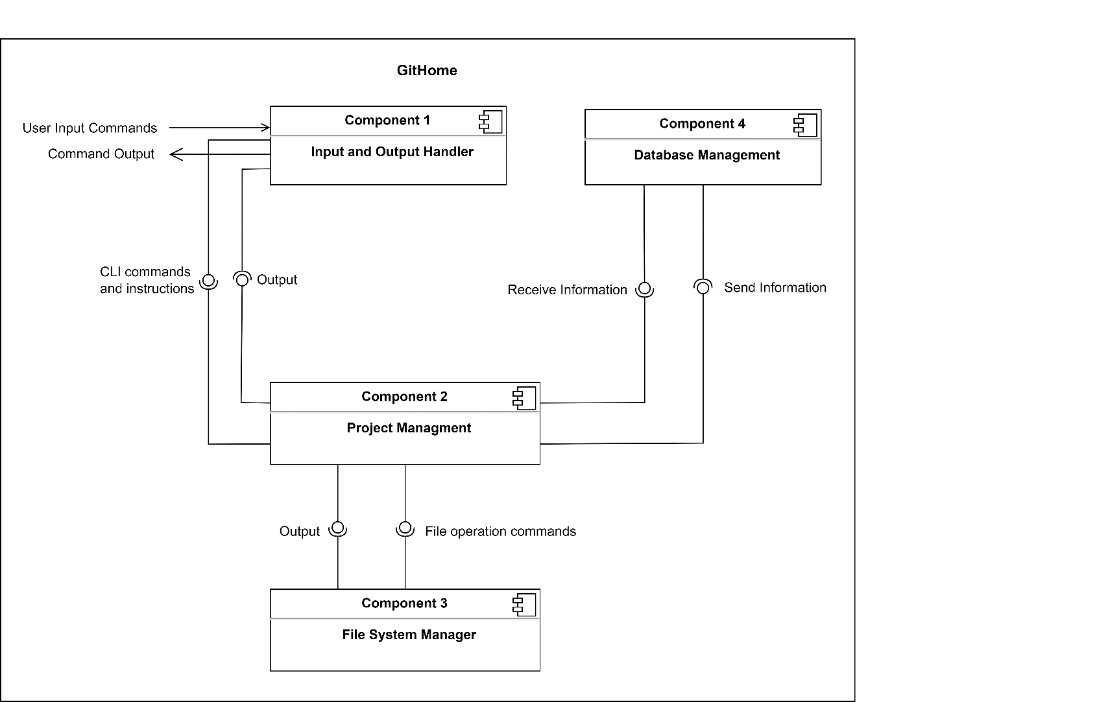

**3. Component Diagram:**

The following Component Diagram shows the details of each module defined in the Architecture Diagram

**Component 1:**

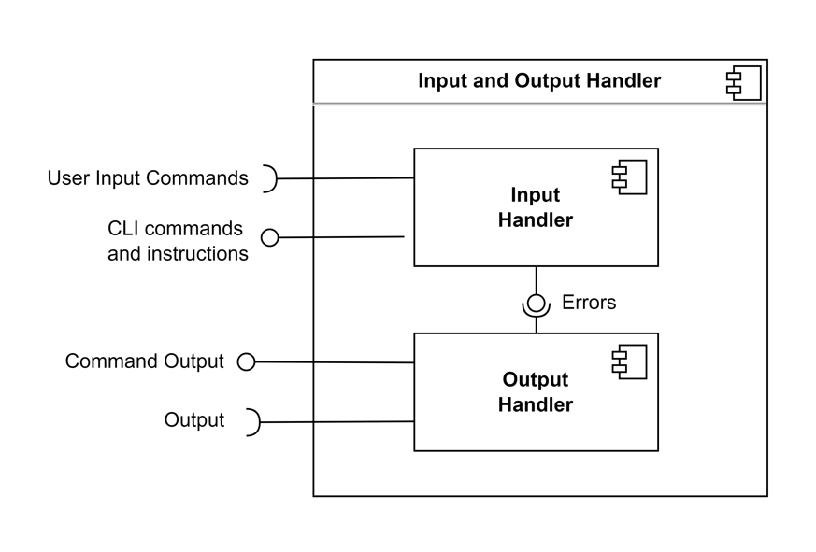

**Component 2:**

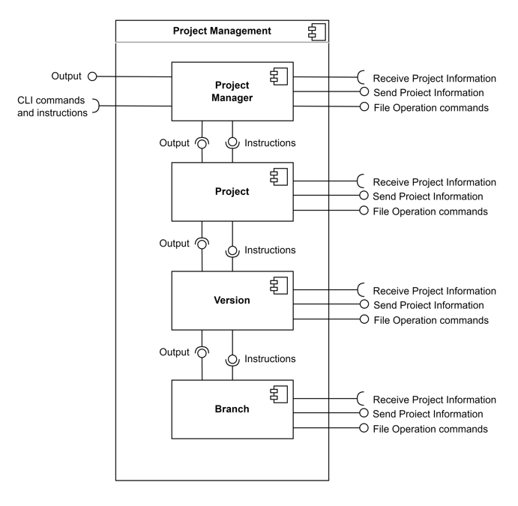

**Component 3:**

**Component 4:**

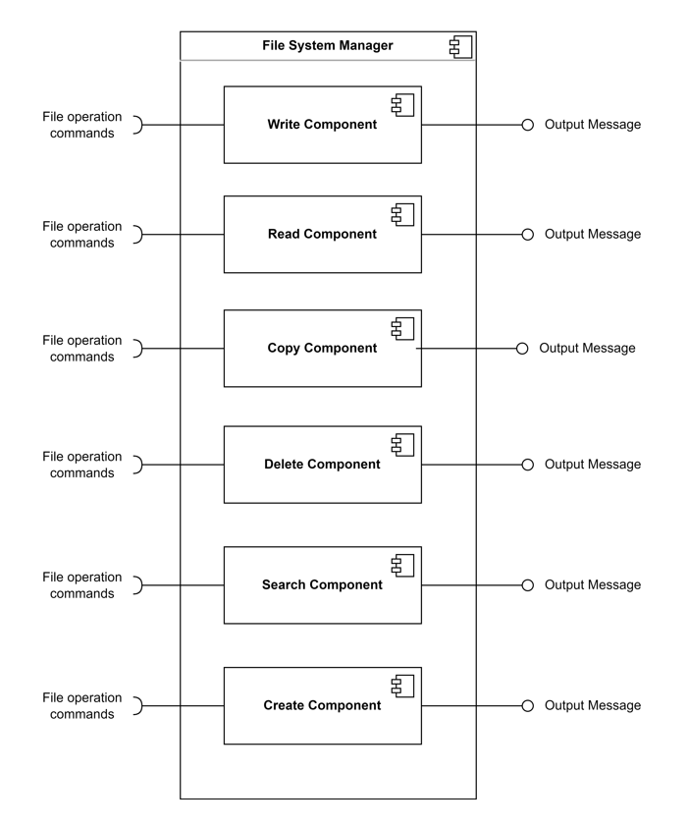

**4. Class Diagram:**

**5. Sequence Diagram:**

**Project Management:**

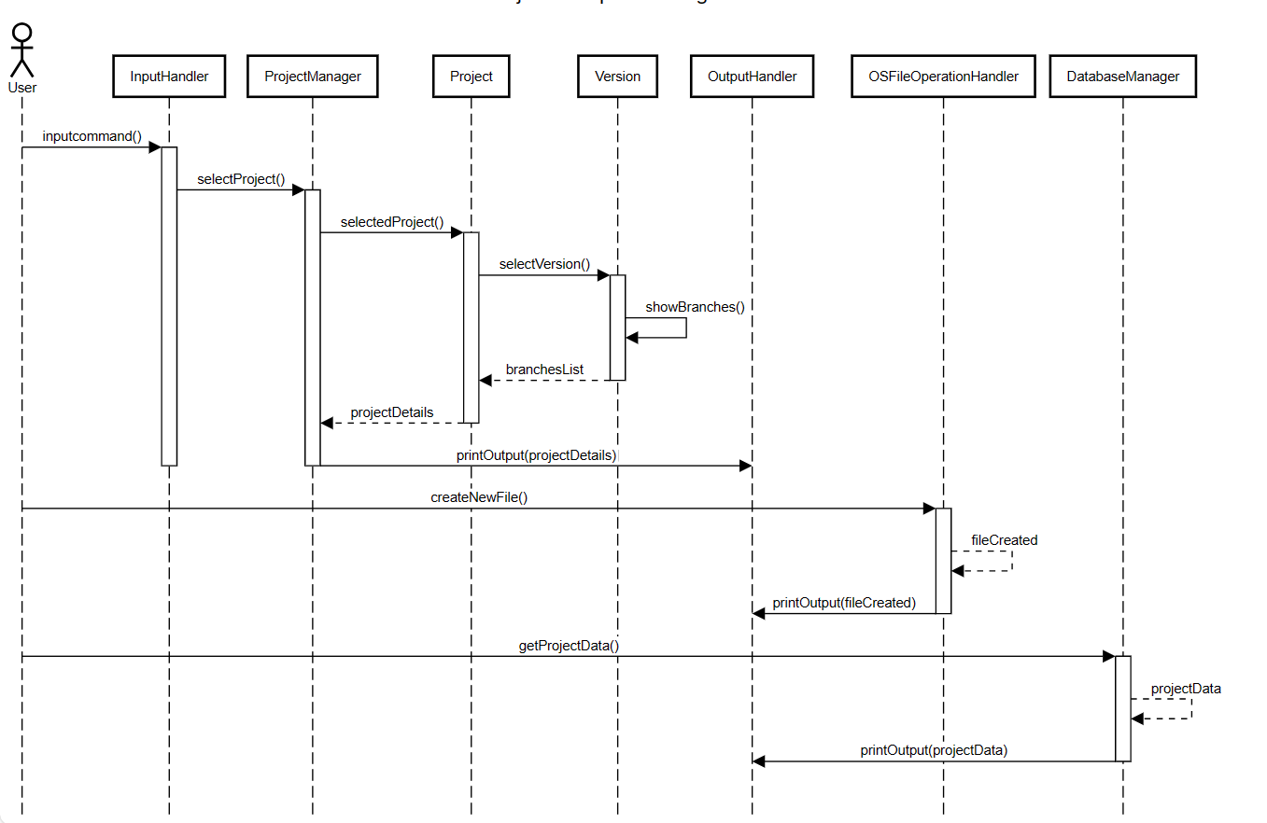

**Version Management:**

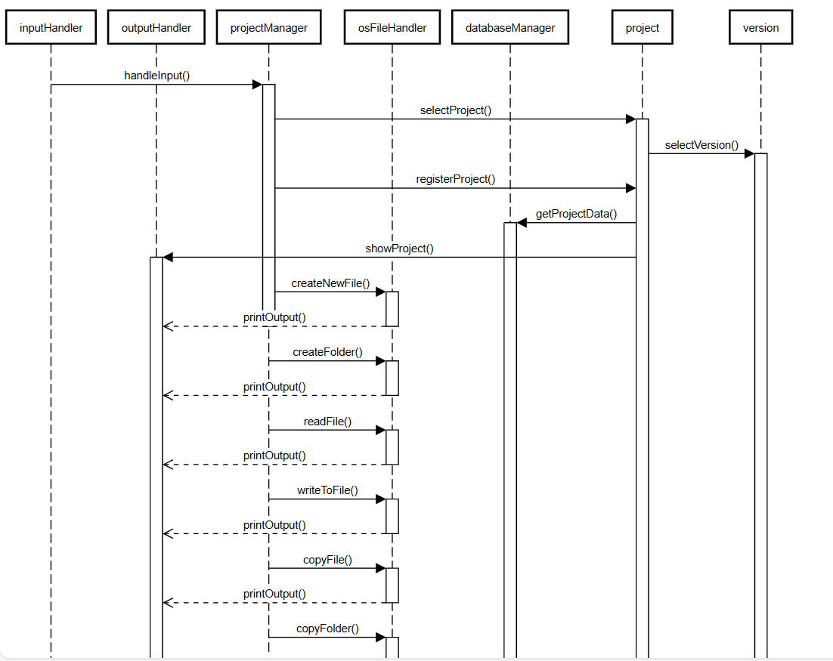

**Branch Management:**

